Contact Info

Jeanclyde Cruz

[cruzjc@hawaii.edu](mailto:cruzjc@hawaii.edu)

1(808)3898793

Kainani Santos

[kainanis@hawaii.edu](mailto:kainanis@hawaii.edu)

1(808)3730649

Program Idea

* Have game theme around Undertale puzzles that the player solves to progress
* Tile puzzle size will be 5x5
* Have a random tile set with various colors
* Explanation of colors
  + Pink tiles have no effect, and can be walked on freely.
  + Red tiles act as solid walls.
  + Yellow tiles force the protagonist back to the last tile they stepped on (the player's controls are locked in the meantime).
  + Orange tiles change the protagonist's flavor to "Orange".
  + Purple tiles act similarly to the ice tiles in Snowdin Forest; they force the protagonist to the next tile in the direction they are facing (the player's controls are locked in the meantime). Additionally, purple tiles change the protagonist's flavor to "Lemon".
  + Blue tiles vary in function depending on the following factors:
    - If the blue tile is adjacent to a yellow tile, the blue tiles act identically to a yellow tile.
    - If the protagonist's flavor is "Orange", the blue tile acts identically to a yellow tile.
    - If neither of the above conditions is met, the blue tile acts identically to a pink tile.
  + Green tile will cause a fight/battle
* Objective is to get across the puzzle to other side of screen
* Overall Movement will be forward (moving to the right) but you can move up and down (no diagonal movement)
* Minimum solution to puzzle will be preset
* Randomness will give (within 4 adjacent tiles):
  + 15% chance of fighting a monster (green tile)
  + 15% change of nothing (pink tile)
  + 30% encountering a wall (yellow or red tile)
  + 15% encountering wild tile (blue)
    - 5% blue becomes yellow
    - 5% your orange flavor
    - 5% blue becomes pink
  + 15% encounter flavor change (orange tile)
  + 15% encountering purple tile

(More or less 100%)

Picture of concept shown in game

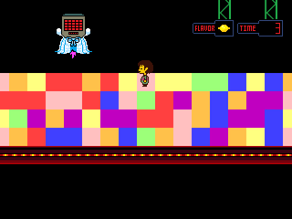

Responsibility Distribution

